MAHARAJA INSTITUTE OF TECHNOLOGY MYSORE
Belawadi, SrirangapatnaTq, Mandya-571477
DEPARTMENT OF CSE (Artificial Intelligence)
 ASSIGNMENT-1 
Find-S and Candidate Elimination Algorithm

Subject Name: Advanced Machine Learning
6th Semester (2026)

Submitted By:

Sl No: | Student Name | USN
1 | Lakshmi L K | 4MH23CA021

Under the guidance of
Dr. Agughasi Victor Ikecheukwu
Department of CSE (AI)

Find-S and Candidate Elimination Algorithm
Background :
Concept learning is a fundamental task in machine learning where the goal is to infer a general rule from specific examples. The Find-S algorithm and Candidate Elimination algorithm are classical approaches used for this purpose.
The Find-S algorithm searches for the most specific hypothesis that fits all positive training examples, ignoring negative examples. In contrast, the Candidate Elimination algorithm computes the entire version space by maintaining a set of all hypotheses that are consistent with the training data.
The version space is bounded by:
- Specific boundary (S): most specific consistent hypothesis
- General boundary (G): most general consistent hypothesis
These algorithms assume:
- Training data is noise-free
- Target concept exists in hypothesis space
- All attributes are categorical

Case Study
In this case study, the goal is to predict whether a person enjoys a sport based on environmental conditions. This problem simulates a real-world decision-making scenario where multiple attributes influence an outcome.
The dataset includes attributes such as:
- Sky condition
- Air temperature
- Humidity level
- Wind strength
- Water temperature
- Weather forecast
The target variable is binary:
- Yes → Enjoys sport
- No → Does not enjoy sport
This dataset is used to demonstrate how hypotheses evolve as more training examples are processed.

Dataset
Sky | AirTemp | Humidity | Wind | Water | Forecast | EnjoySport
Sunny | Warm | Normal | Strong | Warm | Same | Yes
Sunny | Warm | High | Strong | Warm | Same | Yes
Rainy | Cold | High | Strong | Warm | Change | No
Sunny | Warm | High | Strong | Cool | Change | Yes

Each row in the dataset represents a training example.
Positive examples (Yes) help generalize the hypothesis, while negative examples (No) help restrict the hypothesis space.
The dataset is small but sufficient to illustrate how both algorithms refine their predictions step by step.

Code Snippet
import numpy as np

data = [
['Sunny','Warm','Normal','Strong','Warm','Same','Yes'],
['Sunny','Warm','High','Strong','Warm','Same','Yes'],
['Rainy','Cold','High','Strong','Warm','Change','No'],
['Sunny','Warm','High','Strong','Cool','Change','Yes']
]

S = ['0'] * 6
G = [['?' for _ in range(6)]]

for row in data:
attributes = row[:-1]
label = row[-1]

if label == 'Yes':
for i in range(len(S)):
if S[i] == '0':
S[i] = attributes[i]
elif S[i] != attributes[i]:
S[i] = '?'

G = [g for g in G if all(g[i] == '?' or g[i] == S[i] for i in range(len(S)))]

else:
new_G = []
for g in G:
for i in range(len(S)):
if g[i] == '?':
if attributes[i] != S[i]:
new_h = g.copy()
new_h[i] = S[i]
new_G.append(new_h)
G = new_G

print("Final Specific Hypothesis S:", S)
print("Final General Hypothesis G:", G)

The implementation initializes the most specific hypothesis (S) and the most general hypothesis (G). It iterates through each training example and updates S and G based on whether the example is positive or negative. The final output represents the learned hypothesis boundaries.

Output
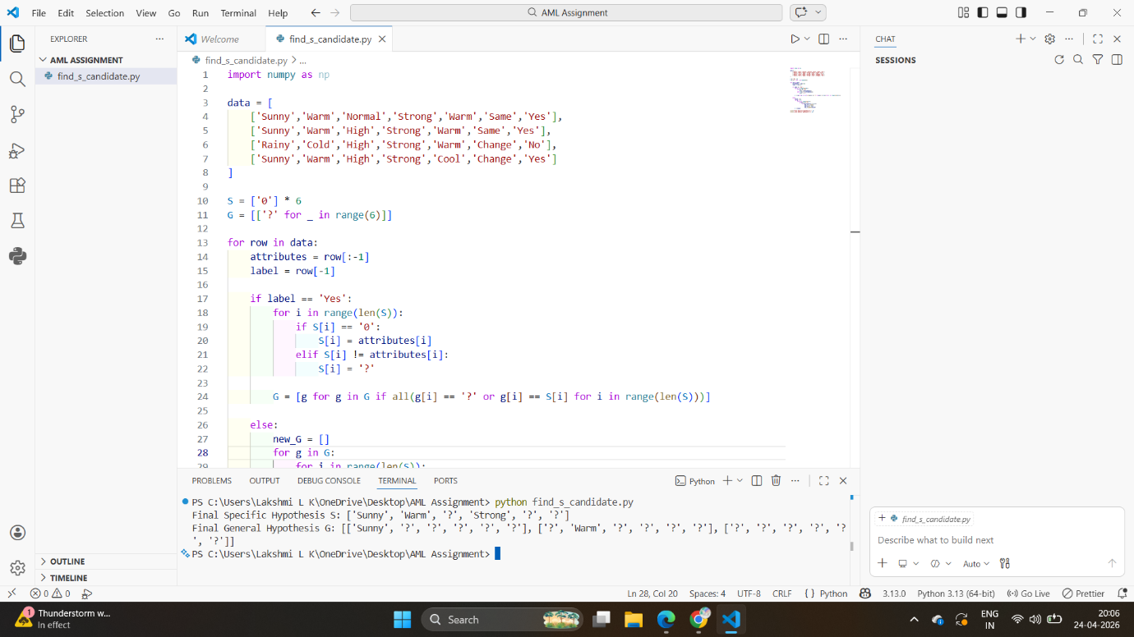
The output shows the final Specific boundary (S) and General boundary (G). These boundaries define the version space, which contains all hypotheses consistent with the training data.

How I Traced It
The tracing process begins with initializing:
- S as the most specific hypothesis
- G as the most general hypothesis
For each training example:
- If the example is positive, S is generalized minimally to include it
- If the example is negative, G is specialized to exclude it
At each step, inconsistent hypotheses are removed to maintain only valid candidates. This iterative refinement continues until the final version space is obtained.

Situations Where Version Space is Impossible
- Noisy Data
If conflicting examples exist (same input but different outputs), no consistent hypothesis can be formed.
Example: Same weather conditions labeled both Yes and No.

- Missing Attribute Values
Incomplete data prevents accurate comparison and updating of hypotheses.
Example: Missing humidity value leads to ambiguity
- Continuous Attributes
Algorithms require discrete values. Continuous attributes create infinite hypothesis possibilities.
Example: Temperature values like 30°C, 31°C, etc.
- Irrelevant Attributes
Unnecessary attributes increase hypothesis complexity without contributing to prediction.
Example: Including ID number as an attribute.
- Inconsistent Hypothesis Space
If the actual concept cannot be represented in the hypothesis space, learning fails.
Example: XOR-type relationships.

Advantages and Limitations
Advantages:
- Provides complete hypothesis space (Candidate Elimination)
- Simple and easy to understand
- Useful for concept learning
Limitations:
- Cannot handle noisy data
- Requires discrete attributes
- Computationally expensive for large datasets
- Fails if assumptions are violated

Conclusion
This assignment demonstrates the working of Find-S and Candidate Elimination algorithms in concept learning. While Find-S identifies a single hypothesis, Candidate Elimination maintains all possible consistent hypotheses through version space. However, both algorithms are sensitive to noise and require well-structured data, which limits their practical applicability in real-world scenarios.

